Face-to-Face with a Buffalo 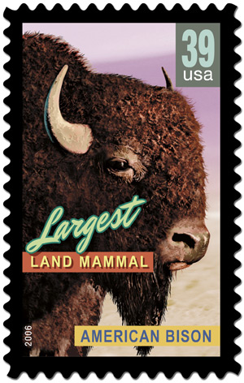

This is not fiction – do not try this anywhere, anytime! You can not even start to imagine how very lucky I am to be alive to tell this story. Jim Bolton

Space Shuttle Solid Rocket Motors are manufactured by ATK ( http://www.atk.com ) outside of Brigham City Utah. I was on a travel assignment to ATK for a four day training course ending with a full-scale Solid Rocket Motor test firing. I elected to travel to Salt Lake City Utah on Sunday (5/20/2007) early morning so that I would have some time to explore and check-out the area. With no real plans I asked the rental car desk clerk to suggest things that I just must see in the area – she told me the Temple and Antelope Island.

I criss-crossed Salt Lake City and visited the Temple – at least the outside, the security to get in was more involved than the airport TSA stuff so I continued on through the city. A city is a city, so I was ready to see what this Antelope Island was all about. Headed north for a few miles and easily found the road to Antelope Island State Park.

Antelope Island State Park is an island that is 15 miles by 7 miles and located in the Great Salt Lake (http://www.utah.com/stateparks/antelope_island.htm ). I went to the marina and decided this salty environment would take a great toll on any vessel in a very short time. I proceeded to the “beach” where I found that it cost $1.75 (in quarters) to use a shower and the concession stand was closed (no change today). I decided: no shower, no swim. From there I went to the Visitors Center. Interesting geology, there are surface rocks here that are 2.7 BILLION years old (the oldest on the planet) which is over ten times older than the earliest dinosaur. There are a number of hiking trails on the island and I thought the 3.6 mile (one way) hike to Frary Peak, the highest point on the island was just what I needed. Looked like that it would allow me to complete the hike and get to the hotel at a reasonable time that evening and I would get some of that altitude that I so enjoy.

As I was leaving the Visitor’s Center there was a life-size metal sculpture of a Buffalo. Some folks think the island should be called Buffalo island because there over 600 wild buffalo on the island. I was amazed at the size and information – over 6 feet tall at the shoulders, 2000 pounds, can run 40 MPH for long distances, can jump 6 feet vertically and 7 feet horizontally, can turn on a nickel, their behavior is UNPREDICTABLE, and are one of the most dangerous animals in North America. Also, they are actually American Bison and only commonly called buffalo (http://en.wikipedia.org/wiki/American_Bison ).

Drove to the Frary Peak trail and applied sunscreen and made sure I had a large bottle of water. At this point, the 3.6 miles trail distance to the peak and 2500 feet of elevation change started looking like a real challenge. I saw the very obvious signs that indicated there was some type of fine if you are on the trail after 6pm. I checked my cell phone and noted that it was 2:10pm, I would keep track of the time and if required I would turn around before the top to avoid this sinister citation that was in big red letters.

The first mile or so was quite steep but I got my second wind and continued on a more gradual section of the trail. Spring was in full swing and the plants and flowers were awesome. The temperature was warm and I had my shirt off with barely the hint of sweat in this dry humidity. I saw a few rabbits, some birds, and many lizards but not one larger animal. At about the half way point I met a group of six hikers coming down, they had not been all the way to the top. Three adults and three boys that seemed to be from 10 to 14 years old and all seemed pretty tired. I chatted for a couple of minutes and continued. I was making very good time and felt that I had found a good pace for me and the terrain that I was encountering.

I came around a mountain switch-back and noticed some changes. I stopped, drank some water, checked the time and was surprised to see that it was only 3:10pm. I could see that there was about another 1500 to 2000 feet of trail distance to the peak. The last 1000 feet was going to be as steep as the first part of the trail. The mountain side was very steep from this point on (30 to 45 degrees), at least most of the time I would be moving perpendicular to the steep face. I had about 200 feet to go before another switch-back at the dead end of this canyon. The sage brush was no longer knee high, it was chest high and seemed to be denser but the trail was quite visible. I launched into what I felt would be the last leg of my hike to the top of Frary Peak. I moved on with renewed vigor and speed longing for the mountain top view and breeze.

I hiked about 100 feet and I had the surprise of my life! A very large buffalo JUMPED up just a few feet from me a ran about 25 feet down the trail. He must have been lying in the sage brush and I startled him. After just a moment I realized that my hopes of going to the top of this mountain were not going to happen today. I started retreating and he snorted and charged at me, I stopped and he stopped. I tried to slowly walk backwards and put some distance between us – he charged again and I stopped and he stopped. At this time we were standing about 10 feet apart with him just off the trail on the down hill side and his shoulders were still above my head. The dead end to the canyon was about 100 feet behind him – he was cornered and I couldn’t go anywhere to help out or he would charge me. I moved as slowly as possible to position the closest sage brush between us and he moved a little closer. I am not sure what I was thinking other than it just felt a little better to have something between us. For this guy, getting through sage brush is like you getting out of a wet paper bag. At least I felt a little protected.

At this point the buffalo seemed calm and content to stand there. I thought about what little I think I know of large animals – you run, they charge; you do anything and they charge; if you wait long enough they just might go away. Every now and then he would put his head down and graze on the short grass; but, most of the time he just looked at me with those big brown eyes. All of a sudden I got a cold chill – what if my cell phone rang with that loud song clip from The Who – “Who, who, whoooo are you !” I very slowly removed my cell phone from the holster and opened it up – it was on vibrate mode! I dialed 911 – not sure what I was going to do, say or what – I just figured that it was a start and they would know I was in trouble. No answer. I tried again, no answer. I looked closer – no service ! ! ! So much for help… I was going to get out of this by myself.

During the next 10 to 15 minutes of standing directly in front of a full grown 2000 pound male buffalo – you can only imagine some of the things that went through my mind. Most importantly, my wife and children and a quick meaningful prayer. The operative word here is meaningful – not just a rote memory thanks to God, because I fully realized this very possibly could be the last one.

During that stand off I thought of a number of things that might allow me to escape this situation. I thought about hollering at him, chasing him, in general being aggressive towards him – this guy’s head is as big as a car door, I’m not scaring him! I thought about throwing my shirt off in some direction to distract him – I can’t throw a shirt far enough! And what’s he going to do – look at it and come get me, he may be dumb but he isn’t stupid and he is BIG and FAST! I thought about squatting down behind the sage brush when he put his head down to graze – that had it’s down sides too, if he realized what I did I’m sure he wasn’t just going to laugh and say “good one dude!” and I really didn’t like the thought of being down low near such a massive beast (talk about vulnerable position!). Run like my pants were on fire – do you remember the Visitor Center lesson (they can run 40 MPH and turn on a nickel)? I remembered, and in this terrain I knew who had the advantage – buffalo all, Jim nothing. I settled in for a long stand just waiting for him to graze his way off into the sage brush – but, how far would be far enough for me to start my retreat? I didn’t dwell on that, I figured it had to be much farther than the 8 feet we were from each other now. Buffalo breath has a new meaning to me – it is real and I assure you it is a derogatory term. I had some time to admire him too – they are very large and the coat is very coarse and the eyes are big and wet and this particular fellow had some impressive sized testicles and did I say that buffaloes are large? I didn’t notice any identification tags or rings attached to this guy. On his right shoulder there was an area of lighter colored fur that was shaped like Illinois. I felt like I was on a mountain with a buffalo with no name. A wild buffalo and I were so far from anywhere or anyone else that I started to feel removed from the scenario. I was getting comfortable with the thought that I would be standing here for a LONG time before he wandered off and that I was hopefully going to find out about that citation for being on the trail after 6pm.

With no warning it happened! He lifted his head, the eyes looked mean and shifty, he snorted and with head down he came through the sage brush like it wasn’t there. I recall the attack in somewhat slow motion, somewhat snapshot images. I saw the right horn coming at my stomach, I put my hands out and tried to deflect the blow. As his head was hitting me I was going up and over his back/shoulders (I prefered the view going over the top much better than the possible view from under). I then crashed down through the sage brush to the rocks below and lying there looked over my shoulder to see that big wet nose inches from my face and it was snorting buffalo snot in my face as he came over me. I have snapshot images of eye, horns, hooves and rock as he trampled me. Instinct and adrenaline is a powerful combination – before I could take conscious control of my actions I was 50 to 60 feet down the trail. I stopped running and looked back, he was standing in the trail snorting and stomping the ground. I speed walked another 30 to 40 feet which took me around a switch back and we were no longer in sight of each other. That was quite a relief!

I continued walking down the trail – from this point on every rock on that mountain looked like a buffalo and every breeze sounded like a buffalo! After a couple of minutes, I took an initial account of my condition – lost bottle of water and cell phone, both knees looked like hamburger and the right one was hurting, multiple scrapes and sore spots and my heart was pounding and my paranoia was in overdrive. I was well aware that I would not survive another encounter with anything larger than a rabbit and I wanted to get off that mountain as soon as possible if not before. I continued down the trail – at one point I thought of how nice it would be if I had my parachute – the wind was favorable and it was a great point to foot launch an open parachute and I’m pretty sure I would have made it to the road down on the coast of the island. This scared me a little because I realized that I was getting desperate to get down and that could lead to some mistakes.

In a short distance I found a rock overhang that provided some shade. I sat down and then thought about the fact that I had not even looked in the recesses and crevasses to see if there were any critters (i.e. rattlesnakes) that were poised to harm me more. Thankfully there were none. I used my shirt to wipe my knees off and determined that I was not losing blood in any significant amounts and there were no bones sticking out. Funny thing, I felt like I had been run over by a buffalo. After a couple of minutes I realized that I could not catch my breath and that my peripheral vision was gone, my focus was fuzzy, everything seemed cloudy and whitish, I was lightheaded and about to faint. I put my head down between my knees and proceeded to cough up blood. An aside here - blood from deep inside has a much different taste and feel than any bloody nose or lip you may have had. I was very scared at this time – if I fainted or passed out under this rock they may never find me. I thought of a quote that I use when training folks in skydiving – “If you don’t run an emergency, it will run you.” -- Cheryl Stearns, 25 time World Champion Skydiver and Airline Pilot. I stood up and started down the trail again. It got more and more difficult as the descent became steeper. Finally I got to the parking lot of the trail! I had made it down 3.5 miles of rocky trail and 2000 feet of vertical descent since the buffalo attack. An elderly man and woman allowed me to have a small amount of water but they seemed scared of me. With great difficulty I got in my rental car and drank that last half inch of melted ice water at the bottom of a soda cup which didn’t even cut the blood taste out of my mouth.

I consulted the park map, the Park Office was about three miles from where I was and that was where I was going. I got there and extracted myself from the car to find that this office was abandoned. Back in the car and another look at the map – the next closest place is the Buffalo Point snack bar (ironic?) about three mile from here. I got there and was relieved to see people. In a daze I walked up and fell in line at the snack bar counter. There was a family of about eight getting ice creams and sodas. One of the boys looked at me in horror – I stepped aside to use a sliding glass door as a mirror. I looked pretty beat up! What was that sticking out over my right shoulder? I reached up and grabbed it, a sage brush limb with my blood on the broken end that had been embedded in my back the whole time. The boy asked if I had been in a fight, and his father looked around as I said “yes, with a buffalo.” The man forcefully herded his family away from me like I may have been dangerous. Then the snack bar attendant saw me and came out, put me in a chair in the shade, got me a bottle of water and called the Park Rangers.

Ranger Haller arrived and I was feeling even worse – the adrenaline was wearing off. He seemed very concerned and did a lot of radio talk just out of hearing range. He did some wound cleanup and asked me a bunch of questions. In a short time the ambulance and airlift helicopter arrived. For a few minutes there was a lot of confusion, then the lead onsite Trauma Doctor started talking to me. She determined that it would be best to transport me by ambulance. Backboard, neck collar, oxygen and the works were used because that’s the procedure and better to be safe than sorry. Once I was loaded in the ambulance with John Boy and Bubba I felt much better. In no way am I making fun of these two guys – they looked and sounded like a couple of John Boy and Bubbas. They were competent and made me feel more comfortable and at ease and I certainly felt that I could trust them to take care of me.

Next stop, Davis County Hospital Emergency Room. I was the center of attention – I later found out that “no one ever survives a wild buffalo attack.” ER work is a blur, x-rays, touch this touch that, ask this ask that, take some blood, give some fluids, CAT scans etc. I must say that one experience was so very novel. I was in the CAT scan and the guy told me that he was going to inject some iodine so that the blood vessels could be imaged better – this would indicate internal injuries to kidneys etc. He said that when he injected it I would feel warm and flush and then like I’m peeing on myself. He assured me that I would not lose control of my bladder. Well, I stopped drinking alcohol in 1999 and when he injected that iodine I felt like I just took a large shot of whiskey – in the mouth, down the throat, into the stomach, and then I was sure I must be flooding the interior of the CAT scan machine with pee – Weirdest thing, I was dry! Due to the circumstances around getting one of these, avoid if at all possible!

Many people were helping me in many ways. One nurse allowed me to use her cell phone to call my wife Jane – oh yea, this is always one of those conversations… Just how do you tell your wife “Hi, I got trampled by a buffalo, walked down a mountain, drove around to find people, transported to the ER and everyone is looking at me like I came from Mars. Other than that I’m just fine Honey.”

At this point Dr. Larsen the surgeon show up looking like I just interrupted his kayaking trip (which I did). Side note here: This man was wonderful to me and I own him great thanks for all he did to help me and the many calls he made to my wife letting her know what was going on and assuring her of my condition. Dr. Larsen informed me that he had studied my CAT scans and other data and I was in very serious and life threatening condition. I had a collapsed left lung, three broken ribs, six fractured ribs, multiple abrasions and bruises. I did not have any other internal injuries or head injuries and appeared to be strong and fairing well under the circumstances. Chest tube was required to drain the blood and other fluids out of the chest cavity and allow the lung to re-inflate. When the procedure started the ER filled up with a number of people that were there to watch and “stand by” in case they were needed – this is not as reassuring as it may sound and I was awake the whole time. It started with a small 1 inch incision in between two of my ribs. Yes, he told me that there would be some air venting when he installed the tube – I just don’t recall him telling me that he was going to put the tube in with a sword! The two and half foot pointed rod that was used to puncture the pluras of my chest cavity was produced out of thin air and rammed into me before I could tell what was happening, immediately followed by a noticeable venting sound and reduced pressure in my chest. Then they attached a water valve vacuum pump device to the tube to suck the blood and fluid out of my chest cavity. Within minutes, I felt that I was going to be better – I was so relieved. The cool stuff was over and the ER emptied out except the Doctor and three nurses. He told me what to expect over the next few days and what things to be concerned about etc. The nurses took care of the assorted abrasions. I think they dug me – they told me that they took care of all kinds of cowboys with some very serious rodeo injuries and I was the bravest one they had ever seen. This may have been some kind of psychology – it worked! I was in a lot of pain but feeling better.

Hospital time is hospital time. I was so very fortunate to have at least a dozen people from Florida that were going to the same training class as I was to attend. They did so many things and provide so much support that I will never be able to thank them enough.

Park Rangers called on me a few times to get additional information about what had happened and what I did and what I saw etc. I seems that no one survives a wild buffalo attack and they were very interested in understanding what went on from a learning perspective. We determined that I startled the buffalo and had him cornered in the canyon and this was the big issue, and it was only a matter of time before he exerted his dominance over me. When he charged me and I went over the top, that may have confused him. Normally they charge their victim, knock them down, and use their massive head as a press and continue crushing until the victim stops breathing, then a little trample for good measure.

The next great event was the removal of the tube. The Doctor explained everything in detail about the removal including the part about “this is going to hurt really bad for a few moments.” Well, once again he left out one crucial part. When I did the breath in and the breath out and he pulled that eighteen inch tube out of my chest like he was starting a lawnmower – now that HURT ! In just a few moments is was all over and I felt another level of improvement, just imagine getting eighteen inches of 3/8” tube out of your chest cavity.

By Wednesday afternoon Dr. Larsen said I would be able to be released on Thursday. Normal release is afternoon, I asked if he could have me released in the morning in time to go see the Solid Rocket Motor test firing. He came in early Thursday morning before his scheduled surgeries and initiated the release activities. I had just enough time to drive to the ATK facility, have lunch and go see the Solid Rocket Motor test firing.

These are a few take-aways from my experience that I would like to share.
- Don’t go hiking by yourself. “Hiking” is not just out in nature, a hike could be visiting a shopping district in a city or visiting a museum or going to a sporting event. If you must go by yourself, at least let someone know where, when etc.
- If you are going to be stupid, you better be tough.
- Save your cell phone contacts list so if you lose your phone you don’t lose all your important contact phone numbers.
- “If you don’t run an emergency, it will run you.” -- Cheryl Stearns, 25 time World Champion Skydiver and Airline Pilot

This photo captures the buffalo look well. Please note that this is a cow not a bull and is 2/3 the size of the one I spent some quality time with at half this distance!
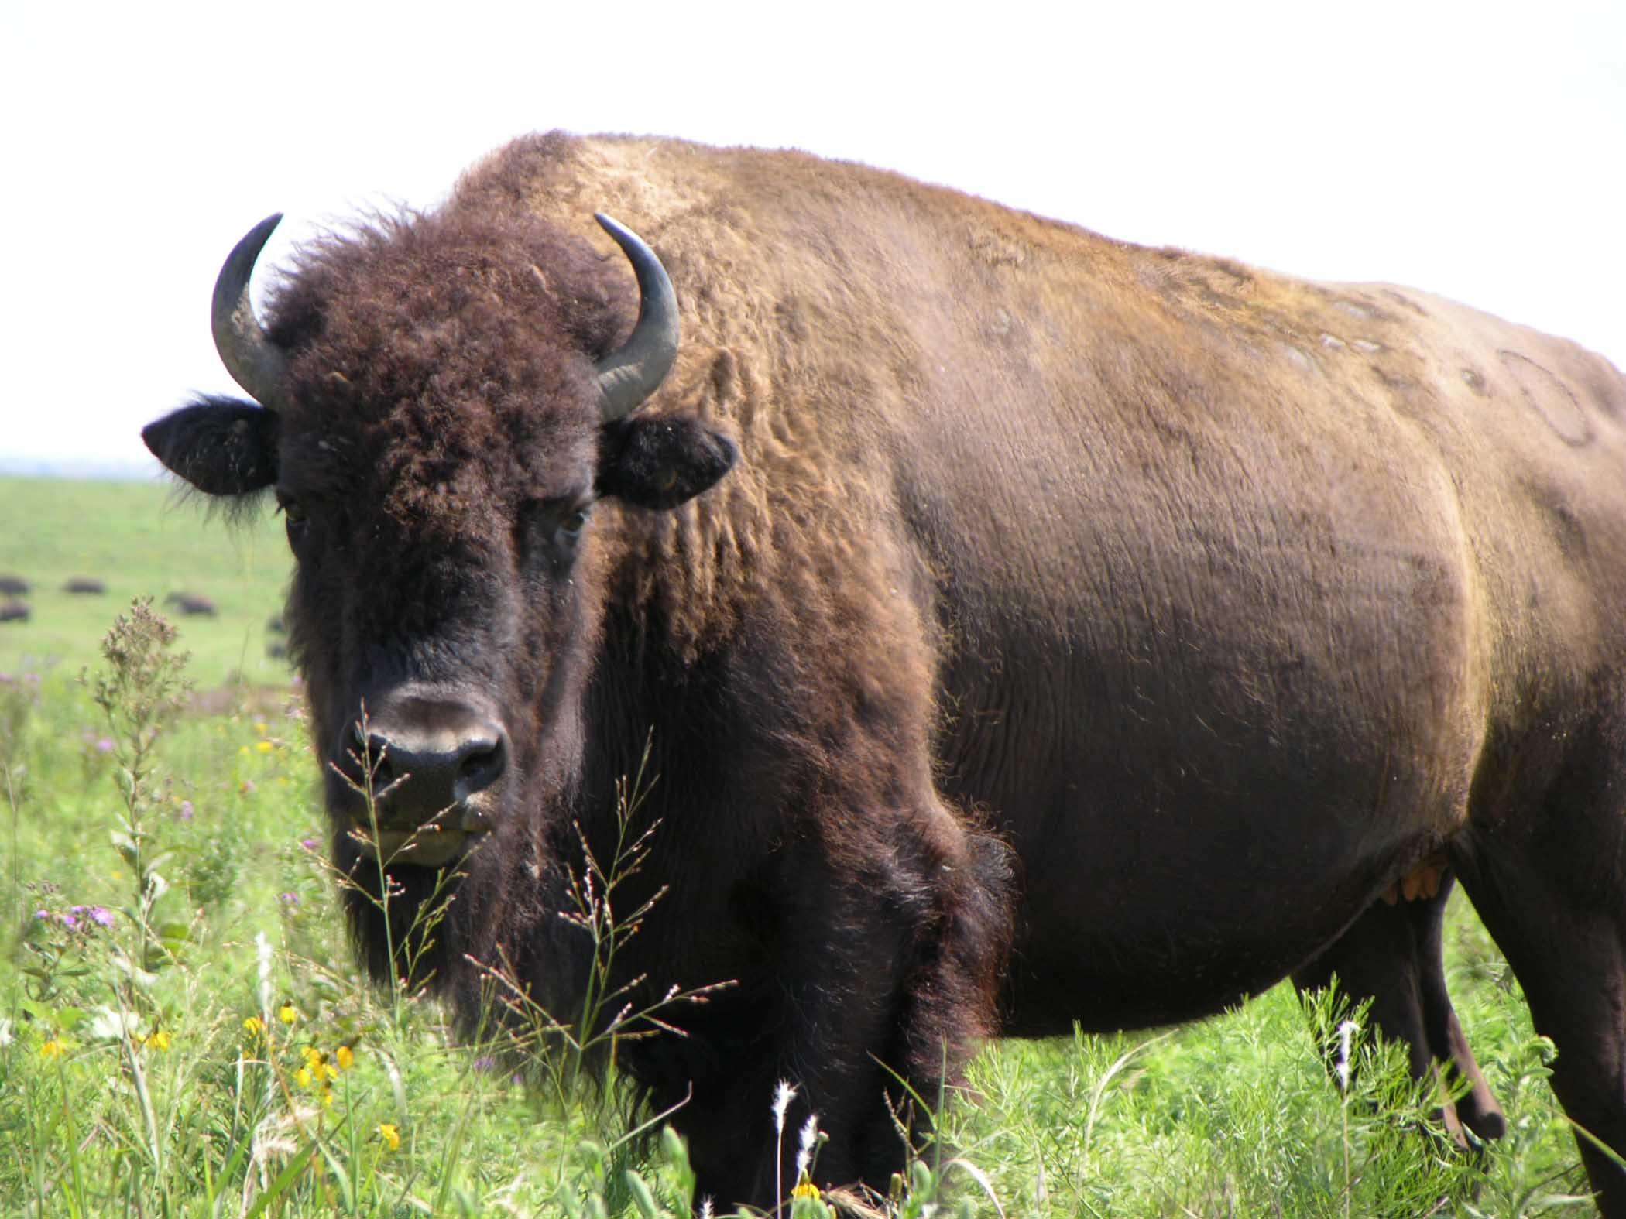

Cell phone photo of my largest and smallest of 5 significant bruises.
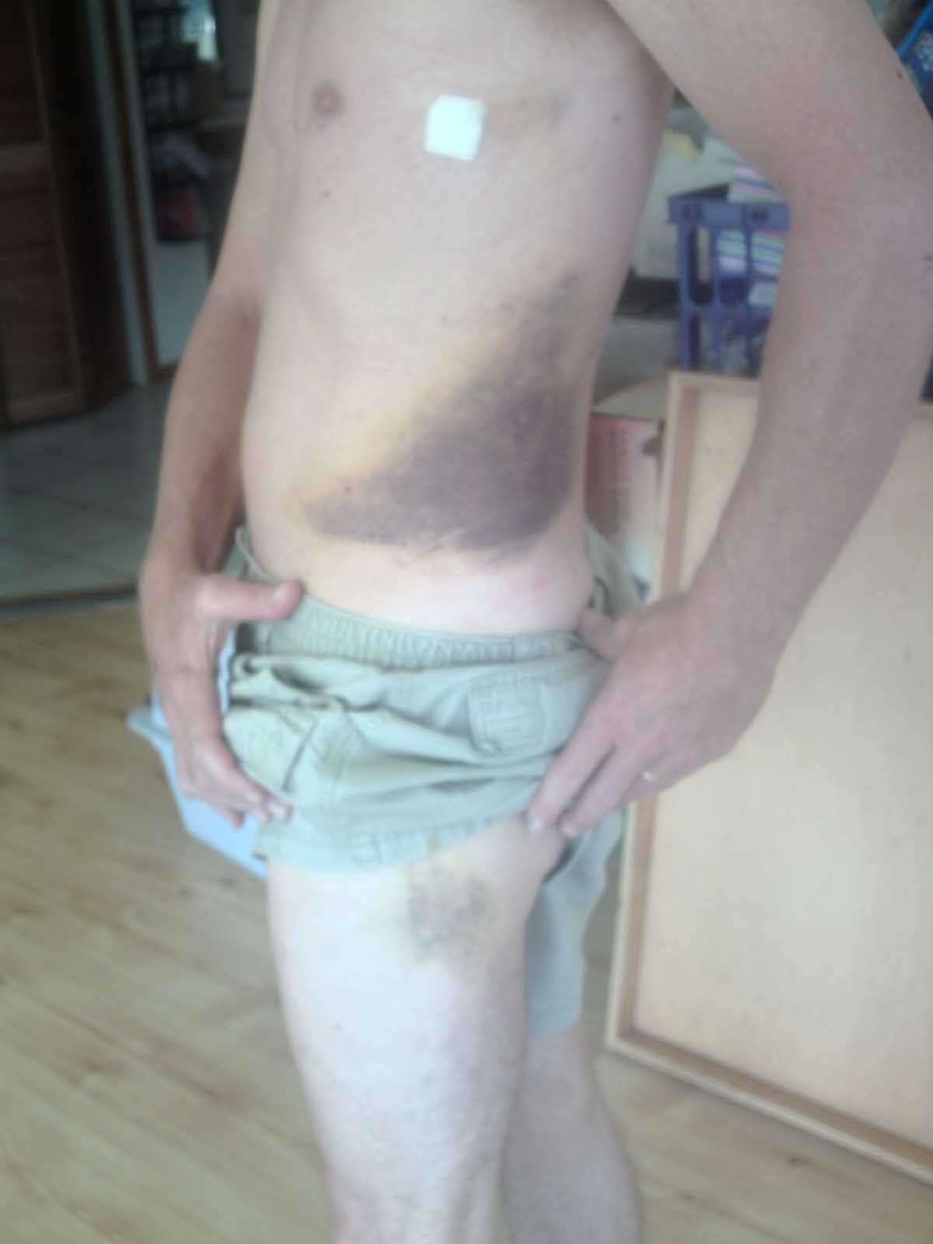
These photos are not to scale!

